C:\Users\director\AppData\Local\Microsoft\Windows\Temporary Internet Files\Content.IE5\TI4TL5ZV\MC900139761[1].wmf\

### 9917 Rea Road

**Waxhaw NC 28173**

**Center Director:**

**Christie Chambers**

**Phone: (704) 841-7777**

**Monthly Newsletter**

**APRIL 2014**

banner with apples and crayons

Where Educational Childcare

has a purpose!



# HAPPY EASTER

**Reminders:**

**Closings:**

On Friday, April 18th– Closing at 3pm (Good Friday)

On Monday, April 21st – Closed (Easter Monday)

**Annual Easter Egg Hunt:**

Will be held on Friday, April 18th at 1:00p.m.-3:00p.m.

**Spring Pictures:**

Will be held on Wednesday, April 9th at 7:30a.m.-11:00 a.m.

**Cap & Gown Pictures:**

Will be held on Wednesday, May 7th at 9:00a.m.-10:00 a.m.

**A.M. Drop Off:**

Please ensure that when you walk your child all the way into class that you are washing your hands and your child’s hands. This will cut down on any germs. Thank you in advance for your assistance in keeping our children as healthy as possible.

**Usborne EZ Book Fair Information:**

Will be held from Mon.4:14- Fri.4:18, more details to come soon.

**Classroom # 11:**

If each parent would please bring in a book bag containing the following items: -sheet, -blanket, -1 or 2 pair of clothes

**Credit Card Charges/Payments:**

As of March 1st, 2014 must be at least $100 or more to be charged.

**Tuition Express/Online Payments:**

Per tuition express the cutoff for daily processing of Tuition Express batched is now 4:00 p.m.

**Annual Curriculum & Registration Fees** are approaching quickly and will be due on May 30th, 2014.

**DSS Families:**

In the near future there will be a portion of the difference charged, more details to come soon.

**Infants thru Toddlers:**

Baby sign: Water

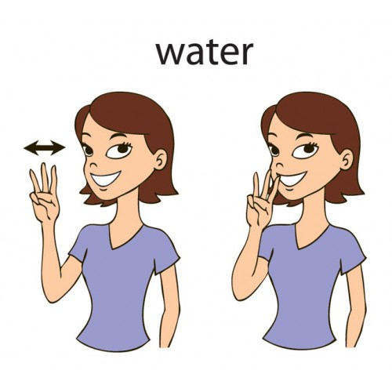

**Two’s thru Four’s:**

Monthly Theme: Reptiles and Amphibians

Monthly Character Values: Fairness

Fairness -to treat people the way you want to be treated; taking turns.

**Afterschoolers**: (Going to 1st grade-up)

Monthly Track: Japan

Monthly Character Value: Fairness



Without inspiration the best powers of the mind remain dormant. There is a fuel in us which needs to be ignited with sparks. Johanna Gottfried Von Herder

Please see me with any questions or concerns!

Miss Christie

# Director Notes:

Like us on Facebook today to see the fun activities your child is participating in and to receive school updates.

Go and post a comment on how awesome your experience has been at the Childrens Lighthouse Waxhaw!

Don’t forget to refer a family and receive a **FREE** week of tuition!

# Parent Referrals/Facebook: